**Credential Renewal flow:**

1) Revoke a credential 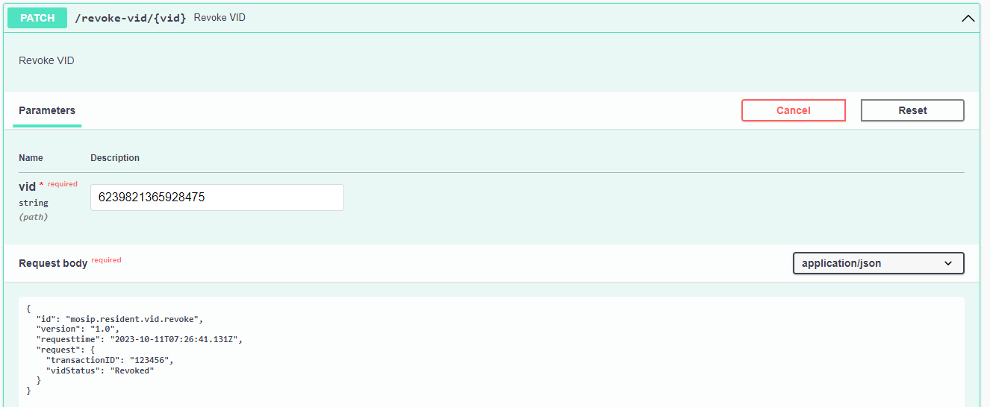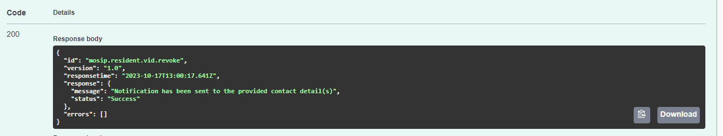

2)Notification received for revoked credential and generated new credential.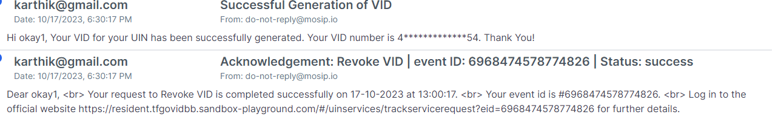

3)Login resident portal with renewed credential.